**MICROPROJECT PROPOSAL.**

**Title:** Recursion using Stacks.

**1.0 Introduction:** **Recursion** in the data structure is when a function calls itself indirectly or directly. A recursive data structure can be defined as a data structure that can be broken down into simple or miniature instances of itself. Recursion in the data structure can be implemented by using Stacks. **Recursion using stack** in the data structure is when functions call themselves directly or indirectly. The process in which a function calls itself could happen directly as well as indirectly**, example** of recursion is keeping books inside the drawer and removing each book recursively.

1. **Aim of the Project:** Implementation of recursion in solving problems.

**3.0Course Outcomes:**

1. Perform basic operations on arrays.
2. Apply different searching and sorting techniques.
3. Implement basic operations on stack and queue using array representation.
4. Implement basic operations on Linked List.
5. Implement program to create and traverse tree to solve problems.

**4.0 Literature Review:**

**1.Fibonacci series:**

A series of numbers in which each number(Fibonacci number) is the sum of the two preceding numbers.

Ex: 0,1,1,2,3,5,8,13,21 etc. The first two numbers of the Fibonacci series are 0 and 1

**2. GCD (Greatest Common Divisor) :**

As per the LCM method , we can obtain the GCD of any two positive integers by finding the product of both the numbers and the least common multiple of both numbers.

Ex: GCD of 2 and 4 :

There are two common factors of 2 and 4, that are 1 and 2. Therefore the GCD of 2 and 4 is 2.

**3. Tower of Hanoi:**

It is a mathematical puzzle or game consisting of three rods and several disks of various diameters, which can slide onto any rod.

Ex: we have three rods a, b and c, and n disks.

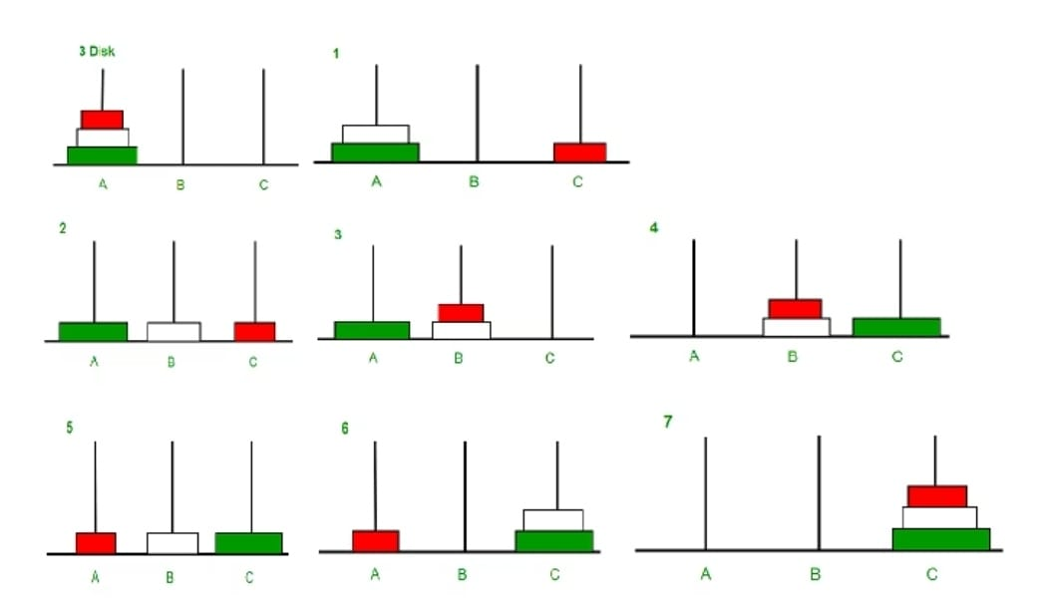

**4. Factorial:**

A factorial is a function in mathematics that multiplies a number (n) by every number that precedes it.

Ex: If n is 3 then the factorial of 3 is 3*2*1 =6.

**5. Hailstone sequence:**

Hailstone sequence follows these rules : If a number is even, divide it by 2 if a number is odd, multiply it by 3 and add 1.

Ex: The hailstone sequence for 13:

13 40 20 10 5 16 8 4 2 1

When number=1 the sequence ends.

**5.0 Proposal Methodology:** This is the menudriven program where all the 5 examples will be implemented by using iterative as well as recursive method.

**6.0 Resources Required:**

|  |  |  |  |
| --- | --- | --- | --- |
| **Sr no.** | **Name of Resources/Material** | **Specifications** | **Qty** |
| **1** | Computer system with broad specifications | Intel Core i5,1Tb SSD,8GB RAM | 1 |
| **2** | Software | VS code | 1 |
| **3** | Chrome | Browser | 1 |

**7. Action Plan:**

|  |  |  |  |  |
| --- | --- | --- | --- | --- |
| **Sr no** | **Details of Activity** | **Planned Start Date** | **Planned finish Date** | **Name of team Members** |
| **1** | Define problem of project | 21-10-22 | 4-11-22 | Patil Rasika Sunil and Deore Samarthya Ravindra |
| **2** | Gather the requirement | 4-11-22 | 11-11-22 | Jain Ekta Vinod and Gangurde Suprabha Dinesh |
| **3** | Designing the microproject | 11-11-22 | 18-11-22 | Deore Samarthya Ravindra |
| **4** | Coding | 18-11-22 | 25-11-22 | Makhija Dhruv Harish |
| **5** | Testing | 25-11-22 | 9-12-22 | Makhija Dhruv Harish and Patil Rasika Sunil |
| **6** | Documentation | 9-12-22 | 20-12-22 | Jain Ekta Vinod and Gangurde Suprabha Dinesh |